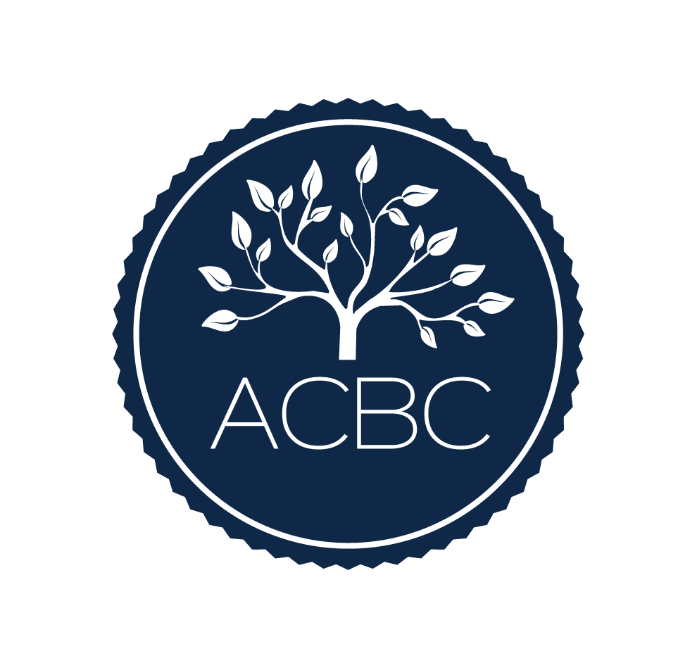

ACBC Required Reading Log
Please record the books you have read from the ACBC Approved Reading List, along with the author and exact number of pages from each book. 1,000 or more pages must be read, with at least 300 pages from the Biblical Counseling & Theology texts. Please submit this form with your ACBC Application.
Applicant Name: Click here to enter text.
Applicant E-mail: Click here to enter text.

Biblical Counseling & Theology Texts
Title of Book | Author | Number of Pages
Total Pages Read (300 or more): Click here to enter text.

Other Books Read from the ACBC Approved Reading List
Title of Book | Author | Number of Pages
Total Pages Read: Click here to enter text.
Combined Total of Pages Read (1,000 or more): Click here to enter text.

ACBC Counselor Observation Log
You are required to observe an ACBC counselor for a minimum of 10 hours. Be sure to provide the information requested below, even if you have watched DVD’s.
Applicant Name: Click here to enter text.
Applicant E-mail: Click here to enter text.
Observation  Date | Name of ACBC  Certified Counselor | Session Length | Running Total

Total Hours Observed: Click here to enter text.

